Program Design Methods and Intro to Programming Python Final Project: Tic-tac-toe



**Student Information:**

Brilian Vincenza Yudha/ 2440123522

**Class Information:**

Class: L1BC

Lecturer’s name: Ida Bagus Kerthyayana / D5757

**Binus University International**

**School of Computer Science**

**2021**

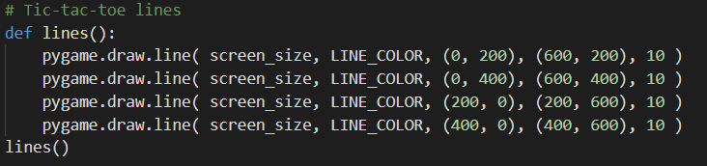

To start off, this tic-tac-toe project, a display is needed. I made it very simple and straight forward. It uses coordinates that is available from pygame directly to set up my lines together. For example (0, 200), (600, 200), would look like this in a 600 x 600 display:

**200**

**200**

**600**

**600**

**0**

What the main loop do:

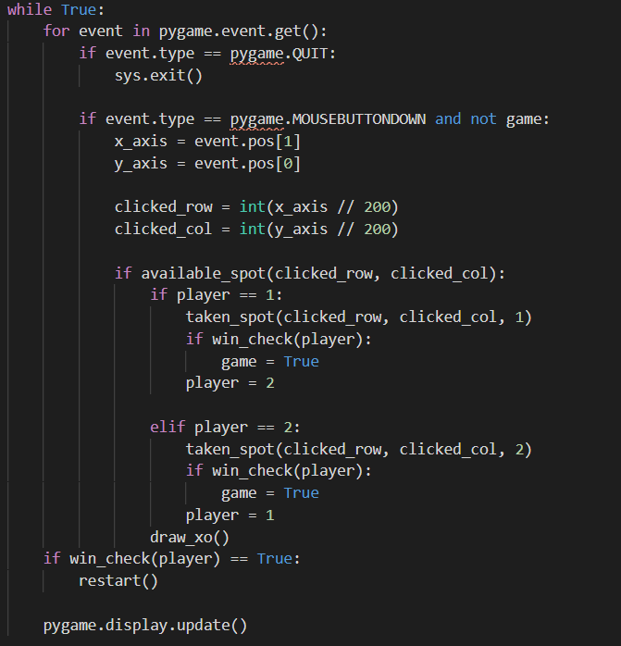

1. Draws X or O for player 1 and 2 on click
2. Switches to between player 1 and 2 between turns
3. Set clicked spots to taken spot and no longer available for either players
4. Checks for available spots
5. Checks whether either player have won the game, if yes the game stops
6. If either player won, restarts the board

How the system checks for winner

The system mainly uses numpy which produces numbers 1 and 2 in a matrix version of tic-tac-toe. For example:

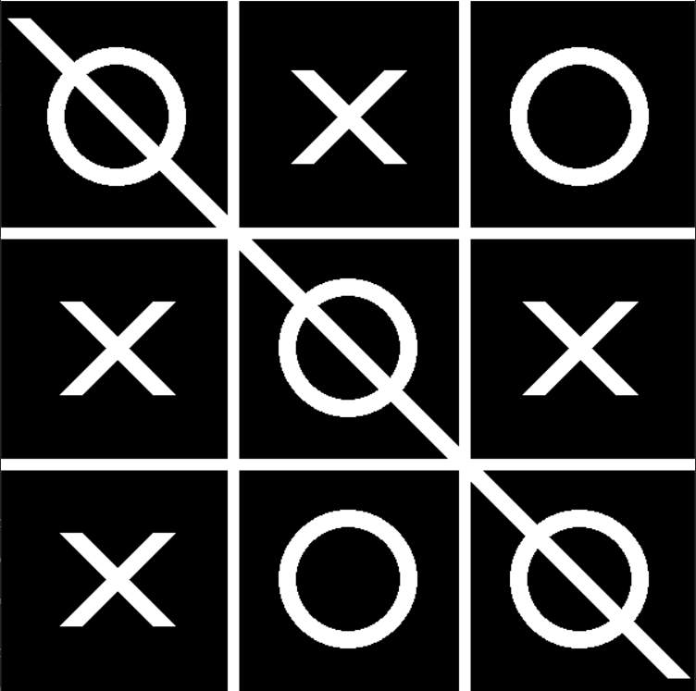

What it looks like on numpy system:

[ [ 1. 2. 1. ]

[ 2. 1. 2. ]

[ 2. 1. 1. ] ]

Since all 1s aligned diagonally, player 1 wins! This is done with:

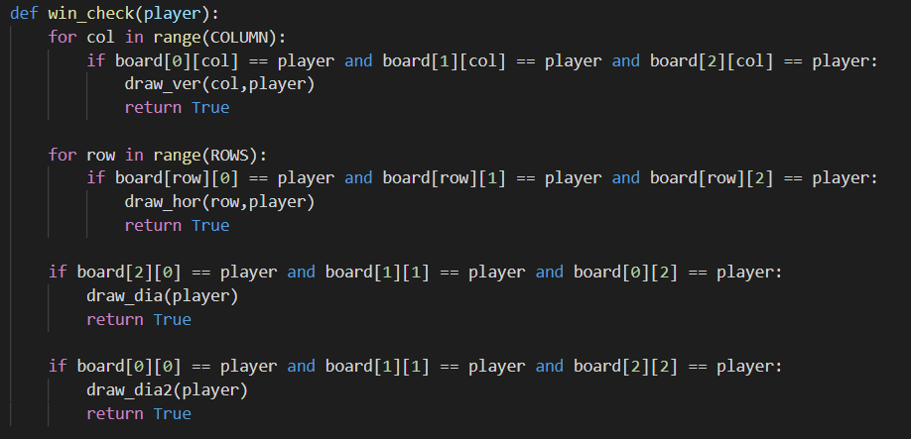

How the win check works is it checks through all column, rows and both diagonals and if it matches the same number on the numpy system mentioned, it will produce a line declaring the winner just like how your typical tic-tac-toe game.